<th>8</th>

<td class="light"></td>

<td class="dark"></td>

<td class="light"></td>

<td class="dark"></td>

<td class="light"></td>

<td class="dark"></td>

# <td class="light"></td>

<td class="dark"></td>

</tr>

<th>7</th>

<td class="dark"></td>

<td class="light"></td>

<td class="dark"></td>

<td class="light"></td>

<td class="dark"></td>

<td class="light"></td>

<td class="dark"></td>

# <td class="light"></td>

</tr>

<th>6</th>

<td class="light"></td>

<td class="dark"></td>

<td class="light"></td>

<td class="dark"></td>

<td class="light"></td>

<td class="dark"></td>

# <td class="light"></td>

<td class="dark"></td>

</tr>

100% Windows (CRLF) UTE-8

<th>6</th>

<td class="light"></td>

<td class="dark"></td>

<td class="light"></td>

<td class="dark"></td>

<td class="light"></td>

<td class="dark"></td>

# <td class="light"></td>

<td class="dark"></td> </tr>

<th>5</th>

<td class="dark"></td>

<td class="light"></td>

<td class="dark"></td>

<td class="light"></td>

<td class="dark"></td>

<td class="light"></td>

<td class="dark"></td>

# <td class="light"></td>

</tr>



<td class="light"></td>

<td class="dark"></td>

# <td class="light"></td>

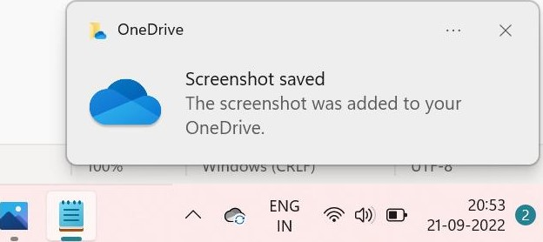<td class="dark"></td>

<td class="light"></td>

<td class="dark"></td>

# <td class="light"></td>

<td class="dark"></td>

</tr>

# <td class="light"></td>

<td class="dark"></td>

</tr>

<th>3</th>

<td class="dark"></td>

<td class="light"></td>

<td class="dark"></td>

<td class="light"></td>

<td class="dark"></td>

<td class="light"></td>

<td class="dark"></td>

# <td class="light"></td>

</tr>

<th>2</th>

# <td class="light"></td>

<td class="dark"></td>

<td class="light"></td>

<td class="dark"></td>

<td class="light"></td>

<td class="dark"></td>

# <td class="light"></td>

<td class="dark"></td>

</tr>

<th>l</th>

<td class="dark"></td>

<td class="light"></td>

<td class="dark"></td>

<td class="light"></td>

<td class="dark"></td>

# <td class="light"></td>

<td class="dark"></td>

100% Windows (CRLF) UTE-8

<td class="light"></td>

<td class="dark"></td>

<td class="light"></td>

<td class="dark"></td>

# <td class="light"></td>

<td class="dark"></td>

<td

</tr>

<th>2</th>

# <td class="light"></td>

<td class="dark"></td>

<td

<td class="dark"></td>

<td class="light"></td>

<td class="dark"></td>

# <td class="light"></td>

<td class="dark"></td> </tr>

<th>l</th>

<td class="dark"></td>

<td class="light"></td>

<td class="dark"></td>

# <td class="light"></td>

<td class="dark"></td>

<td 

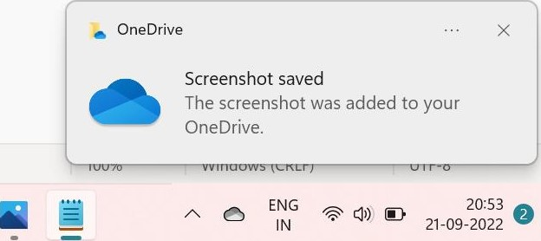<td class="dark"></td>

<td 

</tr>

</table>

</html>

|  |  |  |  |  |  |  |  |
| --- | --- | --- | --- | --- | --- | --- | --- |
| chess.html | | |  | | | | |
| c  Pi G mail | O  YouTube | File I  Maps | | Swayam Central | My Courses | G | Online Courses, PG.. System and Environ... | |

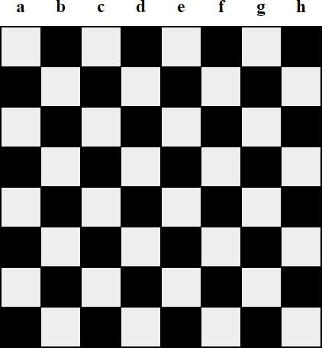8

7

6

5

4

3

2

1

20:59

 vibgyor - Notepad 

File Edit View €93

< ! DOCTYPE html >

(html >

<svg width="8ee"

<circle cx="4ee" r=" 400" stroke="none" stroke-width="2" fill="red" 

r defines the radius of the circle -->

<circle  cy="49"  stroke="none" stroke-width=' '2 " fill=''yellow" / >

<circle  cy="450" r-'- '250" stroke="none" stroke-width= "2 " fill=''green" / >

<circle  cy="450" r--"299" stroke="none" stroke-width=' '2 " fill="blue" / >

<circle  cy="450" r--"150" stroke="none" stroke-width=' '2 " fill=''indigo" / >

<circle  cy="49" r-'- '100" stroke="none" stroke-width= "2 " fill=''violet" / >

</svg>



</html>

Ln 6, col 32 100% Windows (CRLF) UTE-8

21:04

 O

|  |  |  |  |  |  |  |  |
| --- | --- | --- | --- | --- | --- | --- | --- |
| chess.html | |  | | | | | |
| Pi Gmail | O File I  Maps  YouTube | | Swayam Central | My Courses | G | Online Courses, PG... | System and Environ... | |



21:04

File Go

RUN AND DE... No Corv {9

v VARIABLES

# v WATCH

Open home.html: ho... RUNNING

> LOADED SCRIPTS v BREAKPOINTS

Caught Exceptions

Uncaught Exceptions

BROWSER BREAKPOINTS

O x o

home.html > html > head > title

1. < ! doctype html
2. <html
3. <head>
4. <meta charset="UTF-8">
5. <meta name="viewport"
6. content= " width—device-width , user-scalable-no, initial-scale=l.e, maximum- scale=l .0, minimum-sca 7 <meta http-equiv="X-LJA-Compatib1e" content= ' 'ie=edge">
7. <titlefric Tac Toe</title>
8. < link rel=" stylesheet" href="style.css">
9. </head>

## 11

1. <section>
2. <hl class=" game--tit1e">Tic Tac Toe
3. <div class="game--container">
4. <div data-cell-index= "0" class="cell

## 16 <div data-cell-index="l" class="cell

1. <div data -cell -index= "2" class="cell"></div>
2. (div data -cell " class="cell
3. <div data-cell-index="4" class="cell"></div>
4. (div data -cell -index= "5 " class="cell
5. <div data-cell-index="6" class="cell"></div>
6. <div data-cell-index= "7" class="cell"></div>
7. (div data -cell -index= "8 " class="cell
8. </div>
9. <h2 class="game--status"></h2>
10. <button Game</button>
11. < / section>

28

|  |
| --- |
| g, 1 12 selected) paces: |

29

Go

RUN AND DE... No Corv {9

VARIABLES

# v WATCH

Open home.html: ho... RUNNING

> LOADED SCRIPTS v BREAKPOINTS

Caught Exceptions

Uncaught Exceptions

BROWSER BREAKPOINTS

O X

home.html > html > head > title 8 <utIQTic Tac

1. < link href="style.css
2. </head>

## 11

1. <section>
2. <hl class="game--tit1e">Tic Tac Toe</hl>
3. <div class="game--container">
4. (div data-cell-index= "8" class="cell"></div>
5. (div data-cell-index="l" class="cell''></div> 17 (div data -cell -index= "2" class=" cell"></div> 18 <div data-cell -index= "3" class="cell"></div> 19 <div data-cell class=" cell'
6. <div data -cell class="cell"></div>
7. (div data -cell class="cell'
8. (div data-cell -index= "7 " class="cell"></div>
9. <div data-cell-index="8" class=" cell'
10. </div>
11. <h2 class="game--status"></h2>
12. <button Game</button>
13. < / section>

28

## 29 <script src="script.js"></script>

1. < /bodY>
2. </html>

OneDrive

Screenshot saved

The screenshot was added to your OneDrive.

8, col seleclea) spaces: 4 u ' r-ö H iViL

File

O Cl :.css

v

1 const statusDisp1ay = document . querySe1ector( ' . game--status ' ) ;

JS script.js 2

* 1. let gameActive = true;

# style.css

* 1. let currentP1ayer =
  2. let gameState =

6

* 1. const winningMessage = 'Player ${currentP1ayer} has won!'
  2. const drawMessage = "Game ended in a draw! &
  3. const currentP1ayerTurn = ( ) 'It's turn* ,

10

11 statusDisp1ay . innerHTML = currentP1ayerTurn ( ) ; 12

* 1. const winningConditions =
  2. [e, 1, 2],
  3. [3, 4, 5],
  4. 7, 8],

## 17 [e, 3, 6],

### 18 [1, 4, 7], 19 [2, 5, 8], 20 4, 8], 21 [2, 4, 6]

22

23

1. function handleCe11P1ayed(c1ickedCe11, clickedCe111ndex) {
2. gameState[c1ickedCe111ndex] = currentP1ayer;
3. clickedCe11.innerHTML = currentP1ayer;

27

28

29 function handleP1ayerChange()

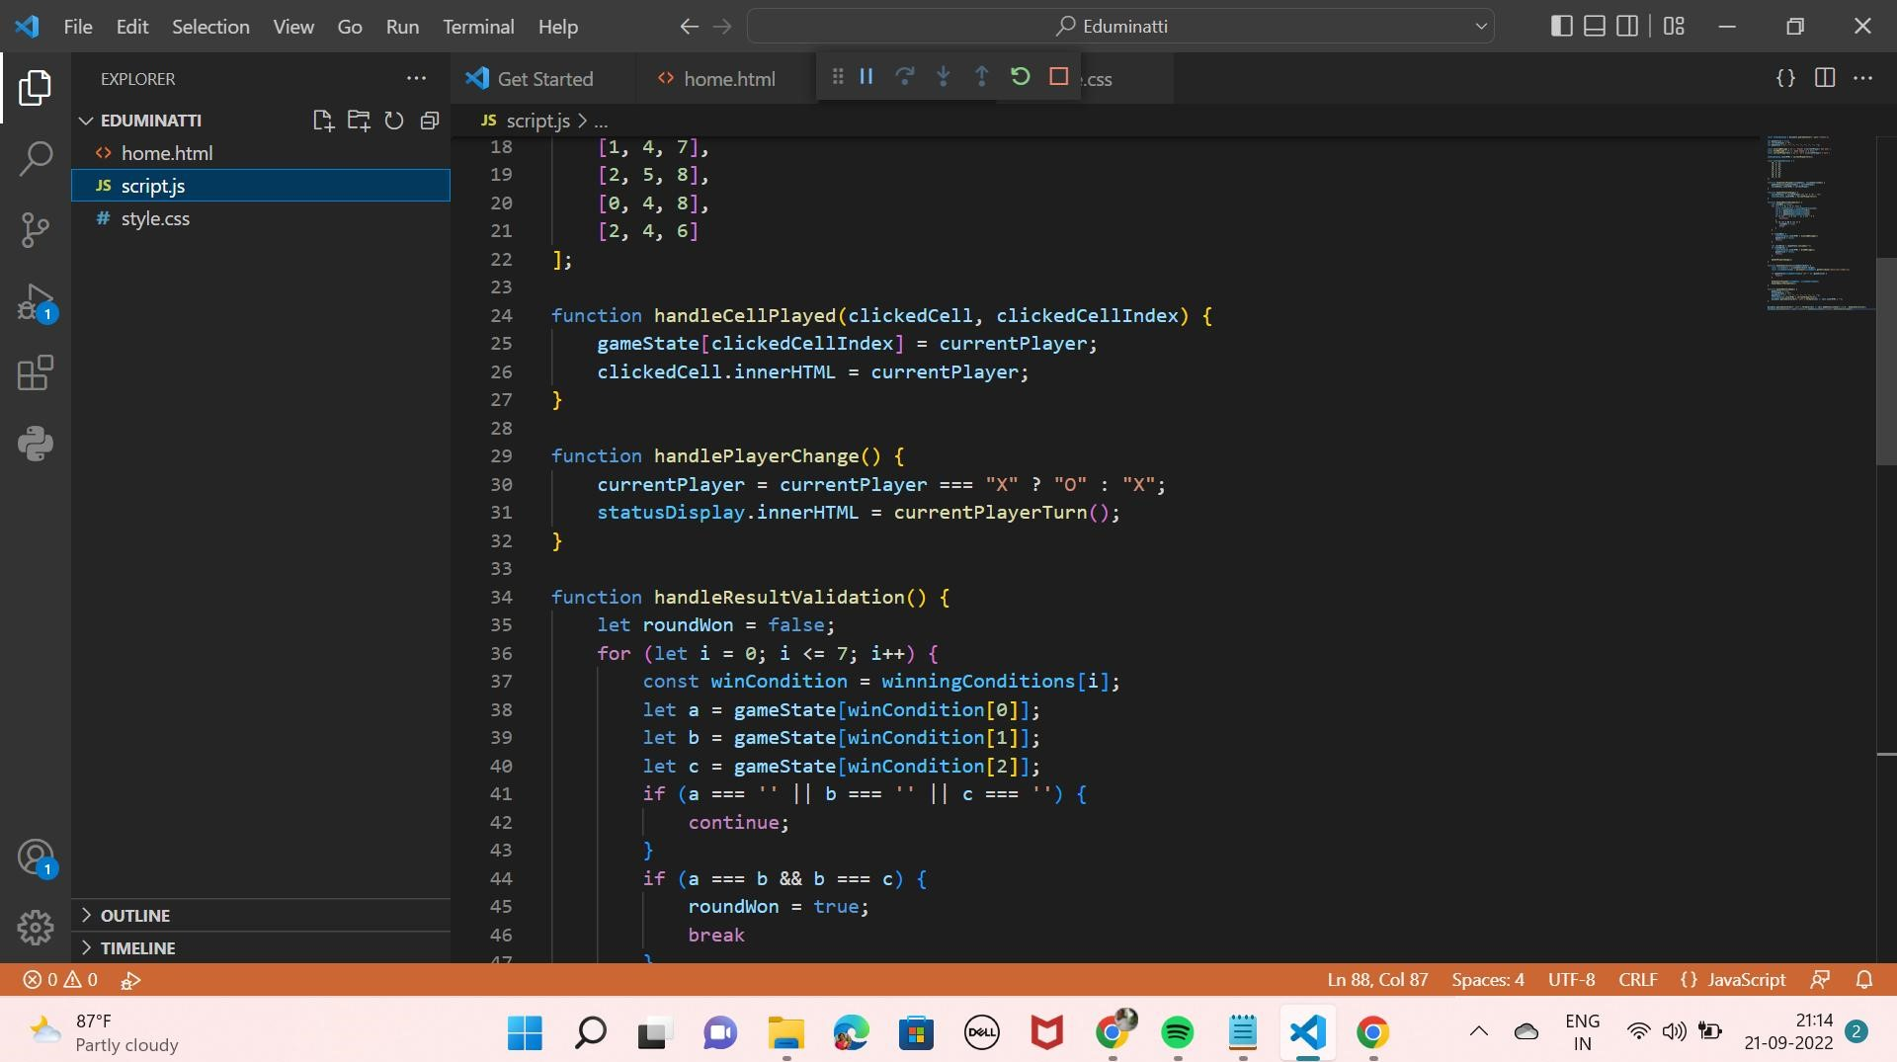

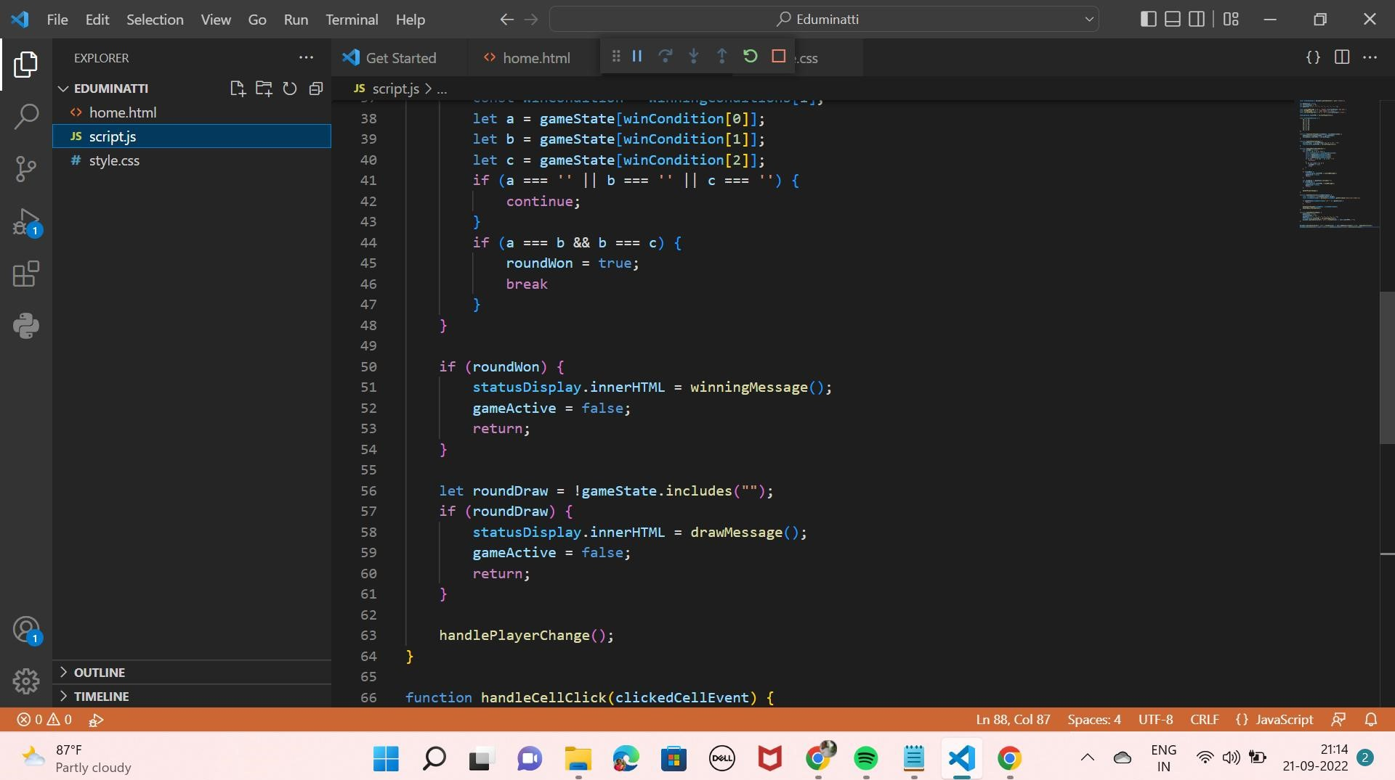

|  |  |  |  |  |
| --- | --- | --- | --- | --- |
|  | 04  65 |  | | |
| JS script.js | 66 | function handleCe11C1ick(c1ickedCe11Event) | | |
| # style.css | 67 | const clickedCe11 = clickedCe11Event.target; | | |
|  | 68  69 | const clickedCe111ndex - parseInt(c1ickedCe11. getAttribute( ' data-cell-index ' ) ) , | | |
|  | 70 | if (gameState[c1ickedCe111ndex] I ! gameActive) { | |  |
|  | 71  72  73 | return; | |  |
|  | 74 | handleCe11P1ayed(c1ickedCe11, clickedCe111ndex) • | |  |
|  | 75  76  77  78  79  8e  81  82 | handleResu1tVa1idation( )  function handleRestartGame() { gameActive = true; currentP1ayer = gameState = statusDisp1ay. innerHTML = currentP1ayerTurn() |  |  |
|  | 83 84  85  86 | document . querySe1ectorA11( ' . cell ' ) . forEach(ce11 | cell. innerHTML = I'" |  |
|  | 87 | document . querySe1ectorA11( ' . cell ) .forEach(ce11 | cell .addEventListener( ' click ' , | handleCe11C1ick)); |
|  | 88 | document . querySe1ector( ' . game- -restart ' ) .addEventListener( ' click ' handleRestartGame ) ; | | |

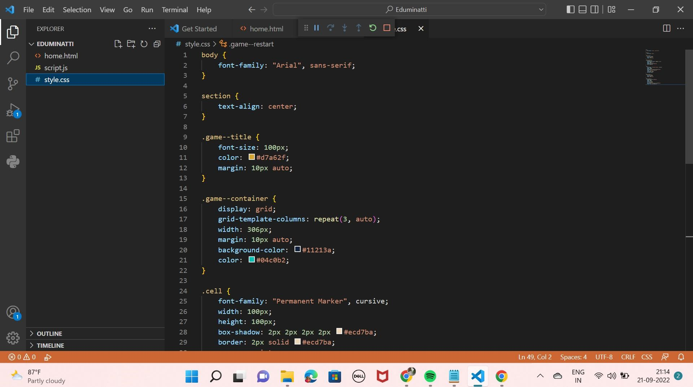

1. width: 306px;
2. margin: lepx auto;

script.js

1. background - color : #11213a;

style.css

1. color: O #04c0b2;

22

23

1. . cell {
2. font-family: "Permanent Marker" , cursive;
3. width: leepx;
4. height: leepx;
5. box-shadow: 2px 2px 2px 2px #ecd7ba;
6. border: 2px solid #ecd7ba;
7. cursor: pointer;

## 31 line-height: leepx; 32 font-size: 68px;

33

34

35 . game- -status {

## 36 font-size: 5epx;

1. color: #d7a62f;
2. margin: 2epx auto;

39

40

## 41 . game- -restart {

1. background - color : #f7e4ac; OneDrive
2. width: 2eepx;
3. height: 5epx; Screenshot saved 45 font-size: 25px; The screenshot to 46 color: O #5586e2; OneDrive.

, co' z spaces: 4 C NLF

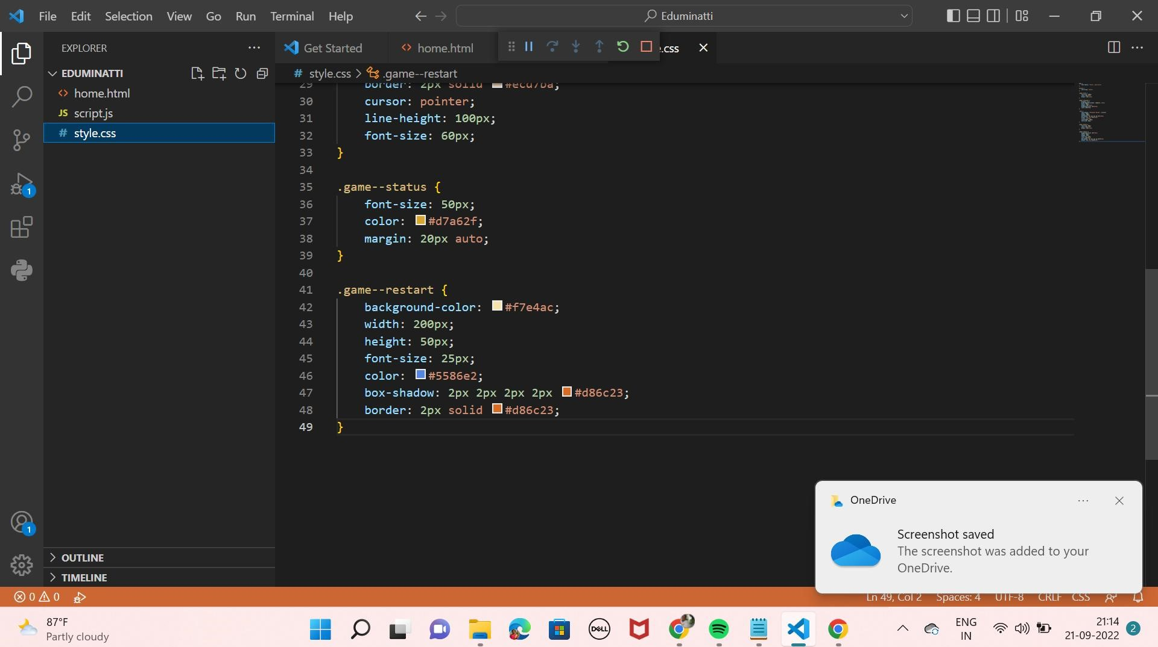

### e Tic Tac Toe x

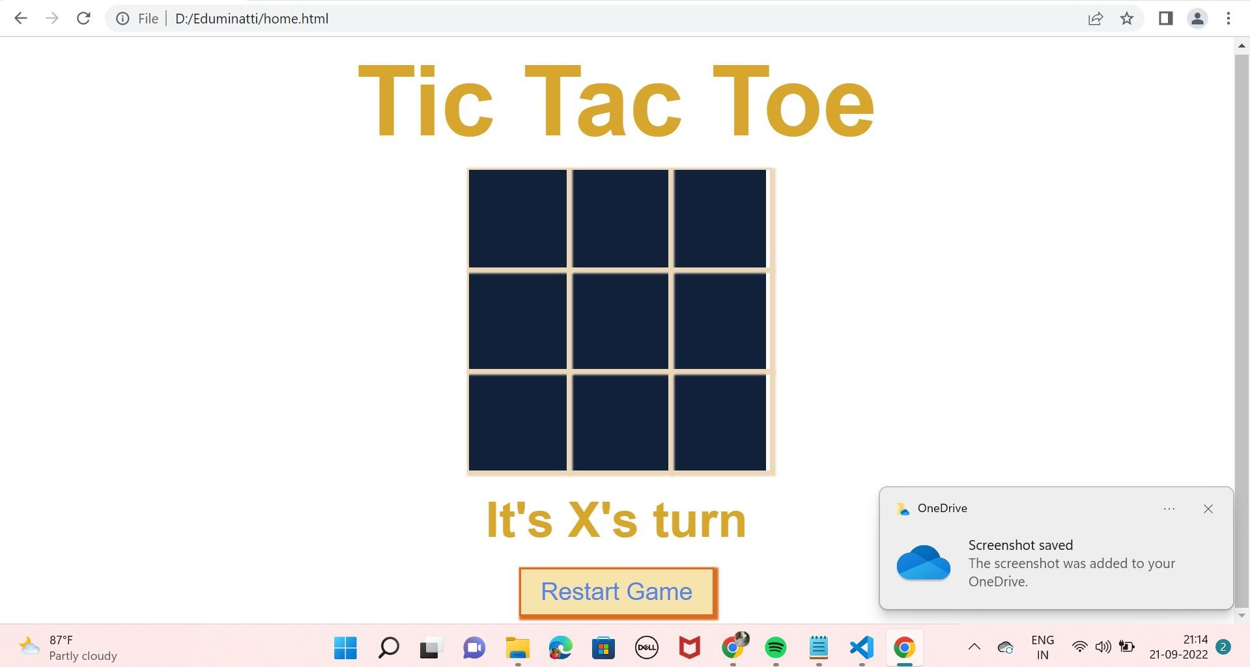



html>

(html >

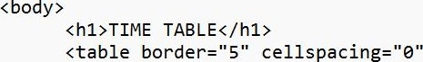 align="center">

< ! --<caption>Timetab1e</caption>-->

<td align="center" width="lee"><br>

<b>Day/Period</b></br>

</td>

<td 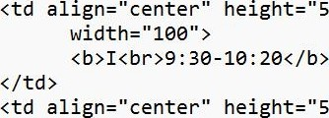align="center" width="lee">



</td>

<td 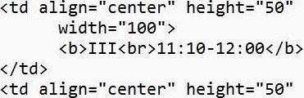align="center" width="lee"> :ee-12 :

</td>

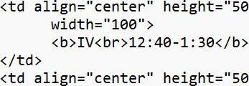

100% Windows (CRLF) UTE-8

</td>

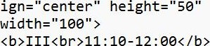

<td

align="center"

</td>

<td align="center" height="50" width="lee">

: ee-12 :

</td>

<td align="center" width="lee">



</td>

<td align="center" height="50" width="lee">



</td>

<td align="center" width="lee">



</td>

<td align="center" height="50" width="lee">



</td>

</tr>

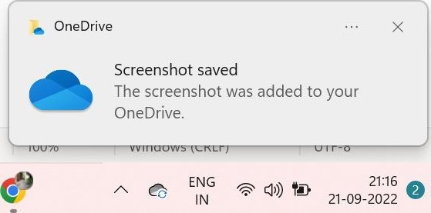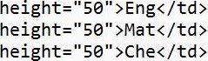<td align="center" height='

<b>Monday</b></td>

<td align="center"

<td align="center"

<td align="center"

<td rowspan="6" align="center" height=" 50" >

<h2>L<br>U<br>N<br>C<br>H</h2>

width="lee">



</td>

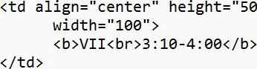

</tr>

<td align="center" height="5e >

<b>Monday</b></td>

<td align="center"

<td align="center"

<td align="center"

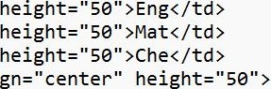<td rowspan="6" align="center"

<h2>L<br>U<br>N<br>C<br>H</h2>

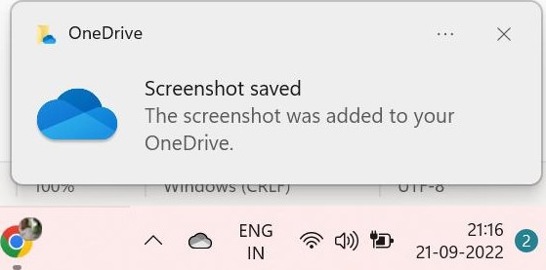</td>

<td colspan="3" align="center" height=" 50" >LAB</td>

<td align="center"

</tr>

<td align="center"

<b>Tuesday</b>

</td>

<td colspan="3" align="center" height=" 50" >LAB

</td>

<td align="center" height="

<td align="center" height=" 50"

<td align="center" height=" 50" >Mat</td>

<td align="center" height='

</tr>

<td align="center"

<b>Tuesday</b>

</td>

<td colspan="3" align="center" height=" 50" >LAB

</td>

<td align="center" height="

|  |  |
| --- | --- |
| <td align="center" | height= " 50" >Mat</td> |
| <td align="center"  </tr> | height=' |
| <td align="center" | height=''59" > |

<td align="center" height=" 50"

<b>Wednesday</b>

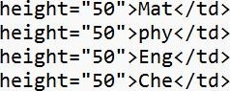<td align="center"

<td align="center"

<td align="center"

<td align="center"

<td colspan="3" align="center"



</td>

<td align="center" height='

<b>Thursday</b>

</td>

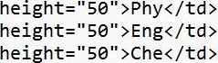<td align="center"

<td align="center"

<td align="center"

<td colspan="3" align="center" height=" 50" >LAB

</td>

<td align="center" 

</tr>

<td align="center" height='

<b>Thursday</b>

</td>

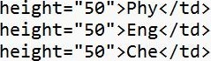<td align="center"

<td align="center"

<td align="center"

<td colspan="3" align="center" height=" 50" >LAB

</td>

<td align="center"

</tr>

<td align="center"

<b>Friday</b>

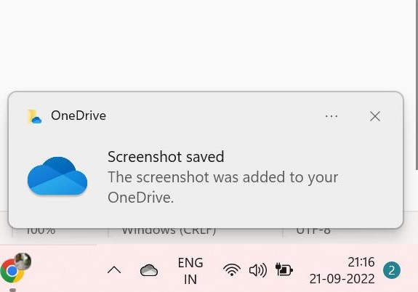</td>

<td colspan="3" align="center" height=" 50" >LAB </td>

|  |  |  |
| --- | --- | --- |
|  | <td align="center" | height=" 50" >Mat</td> |
|  | <td align="center" | height=" 50" |
|  | <td align="center" | height=" |
| </tr> | <td align="center" | height=" 50" |
|  | <td align="center" | height=' |

<b>Saturday</b>

</td>

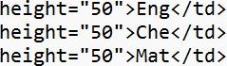<td align="center"

<td align="center"

<td align="center"

<td colspan="3" align="center" height=" >SEMINAR

<td colspan="3" align="center" height=" 50" >LAB

</td>

<td align="center"

</tr>

<td align="center"

<b>Friday</b>

</td>

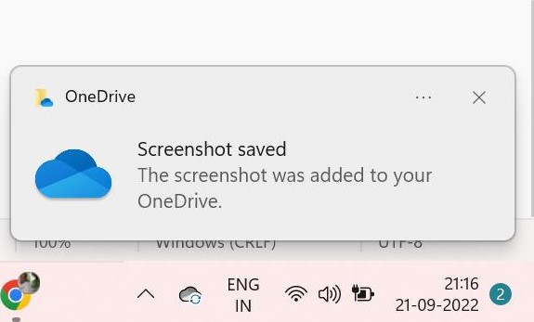<td colspan="3" align="center" height=" 50" >LAB

|  |  |
| --- | --- |
| <td align="center"  <td align="center"  <td align="center"  <td align="center"  </tr>  <td align="center" | height=" 50" >Mat</td> height=" 50" >Che</td> height="      height=" 50"  height=''58" > |

<b>Saturday</b>

</td>

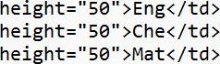<td align="center"

<td align="center"

<td align="center"

<td colspan="3" align="center" height=" >SEMINAR

</td>

<td align="center"

</tr>

</table>

</html>

|  |  |  |  |  |  |  |  |
| --- | --- | --- | --- | --- | --- | --- | --- |
| timetable.html | |  | | | | | |
| Pi Gmail | O File I C:/Users/G%20RENUKA%20DEVl/OneDrive/Documents/timetable.html  YouTube Maps Download WhatsApp TutorOps Dashboard Online Courses | | Swayam Central | My Courses | G | Online Courses, PG | System and Environ... | |

TIME TABLE

|  |  |  |  |  |  |  |  |  |  |
| --- | --- | --- | --- | --- | --- | --- | --- | --- | --- |
| Day/Period | 1 | 11 | 111 | 12:00-12:40 | 12.•40-1:30 |  |  | Vil |  |
| Monday | Eng | Mat | Che |  | LAB | | | Phy |
| Tuesday | LAB | | | Eng | Che | Mat | SPORTS |
| Wednesday | Mat | phy | Eng | Che | LIBRARY | | |
| Thursday | Phy | Eng | Che | LAB | | | Mat |
| Friday | LAB | | | Mat | Che | Eng | Phy |
| Saturday | Eng | Che | Mat |  | | |  |
| SEMINAR | | OneDrive x  Screenshot saved  The screenshot was added to your  OneDrive. | | |
|  | | | | | | |



File 

JS

v home.html > head

1

O home.html 2

1. < ! DOCTYPE html

script.js

1. < html

style.css

1. < head>
2. <meta charset="UTF-8">
3. <meta http-equiv="X-UA-Compatib1e" content="IE=edge">
4. <meta name="viewport" content="width=device-width,

9

10 < link rel=" stylesheet" href="https : //unicons . iconscout . . css " >

11

12 < link rel=" stylesheet" href=" style.

13

14

15 </head>

16

17

1. <div class="container">
2. <div
3. <div class="form login " >
4. < span >Login</span>

22

1. < form action="#">
2. <div class="input-field">
3. < input type="text" placeholder="Enter your email" required>
4. < i class="uil uil-envelope icon"></i>
5. </div>
6. <div class="input-field">
7. < input class="password" your password" required

C01 8

21:24

File Edit Selection View Go Run Terminal Help

EXPLORER Get Started

v EDUMINATTI home.html

> .vscode

34

O home.html

35 script.js 36 style.css 37

38

39

40

41

42 43

44

45

46

47

48

49

50

51

52

53

54

55

56

57

58

59

60

> OUTLINE

61

> TIMELINE 62

p Eduminatti 6 x

home.html JS script.js # style.css • launch.json

> head

<div class="checkbox-text">

<div class="checkbox-content">

<input type=" checkbox" id=" logCheck" >

< label for="10gCheck" " >Remember

</div>

> Forgot password?</a>

</div>

## (div class="input-field button" >

< input type="button" value="Login">

< [div >

< /form>

<div class="login-signup">

<span >Not a member?

<a href="#" class="text signup-link">Signup Now</a>

</span>

</div>

</div>

Registration Form - >

<div class="form signup" >

## < span class="title" >Registration</span>

< form action="#">

<div class="input-field">

< input placeholder="Enter your name" required class="uil

@ O 0 Launch Chrome against localhost (Eduminatti) Col 8

21:24

• JS #

|  |  |  |  |  |
| --- | --- | --- | --- | --- |
|  | home.html | > | head |  |
| caav caass=•• |
| O home.html | 61  62 |  | <input type="text" placeholder=''Enter your n ame" required  < i class="uil uil-user"></i> |  |
| script.js | 63 |  | </div> |  |
| style.css | 64 65  66  67  68 |  | <div class="input-field">  <input type="text" placeholder="Enter your email " required>  < i class="uil uil-envelope icon"></i> </div>  <div class="input-field"> |  |
|  | 69  70  71  72 |  | < input type="password" class="password" placeholder="Create a password"  < i class="uil uil-lock icon"></i>  < [div >  <div class="input-field"> | required> |
|  | 73 74 75  76  77  78  79  80  81  82  83 84 85  86  87 |  | < input type="password" class="password" placeholder="Confirm a password"  <i class="uil uil-lock icon"></i>  < i class="uil uil-eye-slash showHidePw"></i>  < [div >  <div class="checkbox-text">  <div class="checkbox-content">  <input type=" checkbox" id="termCon"> | required |
| < label class="text">l accepted all terms and conditions</label>  </div>  </div>  (div class="input-field button" >  < input type="button" value="Signup" >  < [div > | |
|  | 88 |  | < /form> | |

Col 8

|  |  |  |  |  |  |  |
| --- | --- | --- | --- | --- | --- | --- |
| "  88  89  90   1. >A1ready 2. <a class="text   93  94  95  96  97  98 99 lee lei le2  103  > | p Eduminatti |  |  |  |  | 6 x |
| style.css launch.json  button " > value="Signup" >      login-link">Login Now</a> | | | | | |
|
|
|
|
| TIMELINE  @ O 0 Launch Chrome against localhost (Eduminatti) Ln 15, Col 8 Spaces: 4 UTE-8 CRLF HTML | | | | | | |



 JS # {l

JS script.js

|  |  |  |  |
| --- | --- | --- | --- |
|  | 1 | const container = document . querySe1ector ( " . container" ) , |  |
| home.html | 2 | pwShowHide = document. querySe1ectorA11 ( " . showHidePw") , |  |
| JS script.js | 3 | pwFie1ds = document . querySe1ectorA11 ( " . password" ) , |  |
|  | 4 | signUp — document . querySe1ector( " . signup -link" ) , |  |
| style.css | 5  6 | login = document . querySe1ector ( " . login-link" ) ; |  |
|  | 7 | pwShowHide. forEach(eyeIcon =>{ |  |
|  | 8 | eyelcon . addEventListener("click", |  |
|  | 9  10  11  12 13 | pwFie1ds.forEach(pwFie1d =>{ |  |
| if(pwFie1d.type "password") { pwFie1d. type = "text" ;  pwShowHide.forEach(icon |
|  | 14 15  16  17  18  19 | icon . classList. replace( "uil-eye- slash " ,  }else{ pwFie1d.type = "password";  pwShowHide.forEach(icon =>{ | "uil -eye" ) ; |
|  | 20  21  22  23 24 | icon . classList. "uil-eye-slash"); | |
|  | 25  26 | OneDrive | |
|  | 27 | signUp. addEventListener ( " click" , Screenshot saved | |
|  | 28 | container. classList. add( " active" ) ; The screenshot was added to your | |
|  | 29 | OneDrive.  Ln 21, co' paces: U lr-ö CKLI- java5cnpt | |

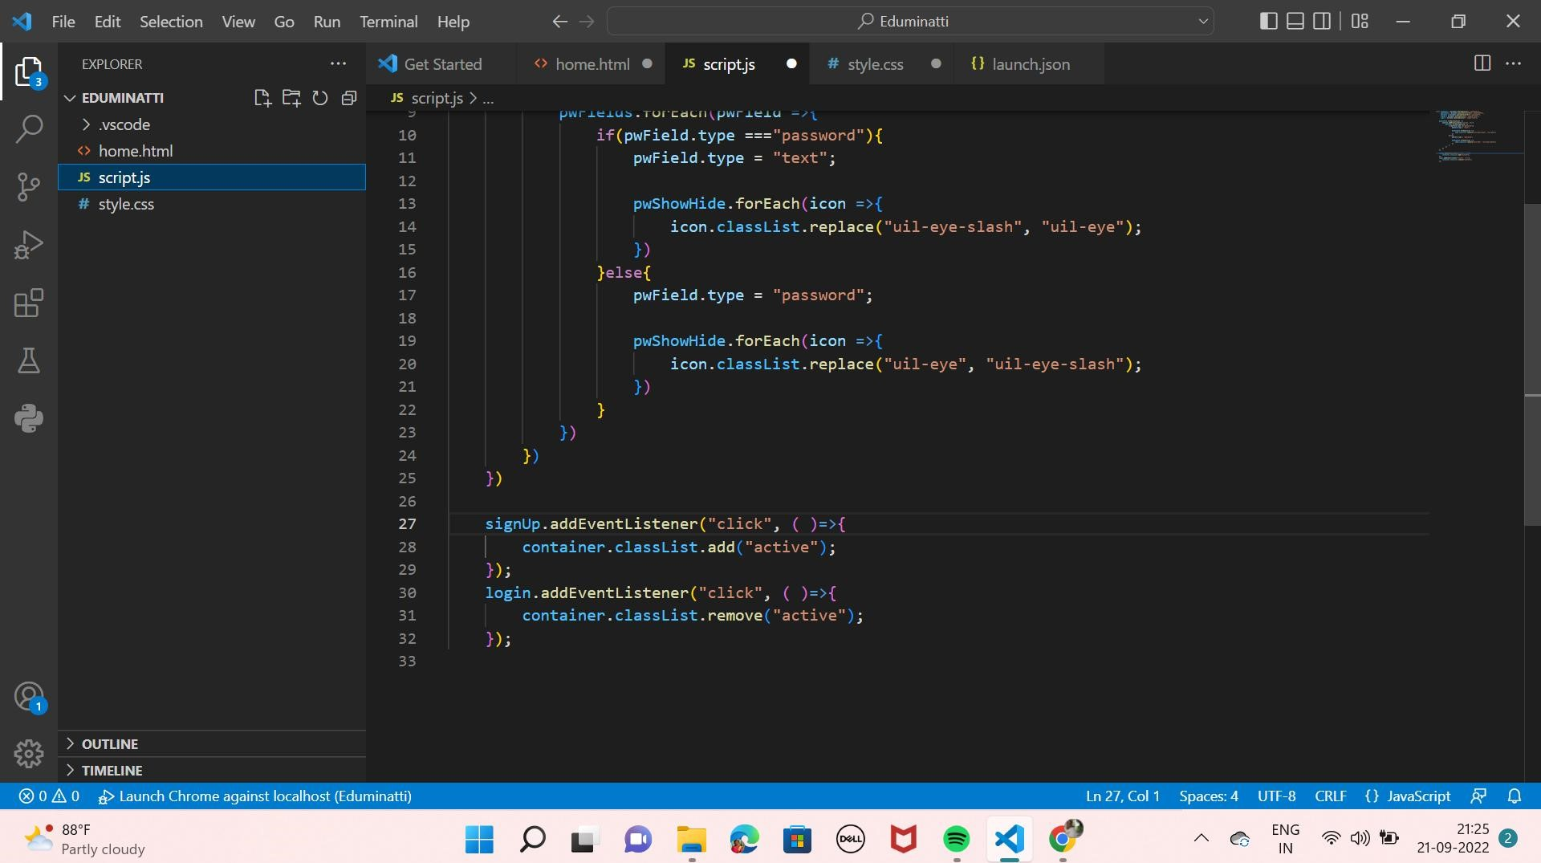

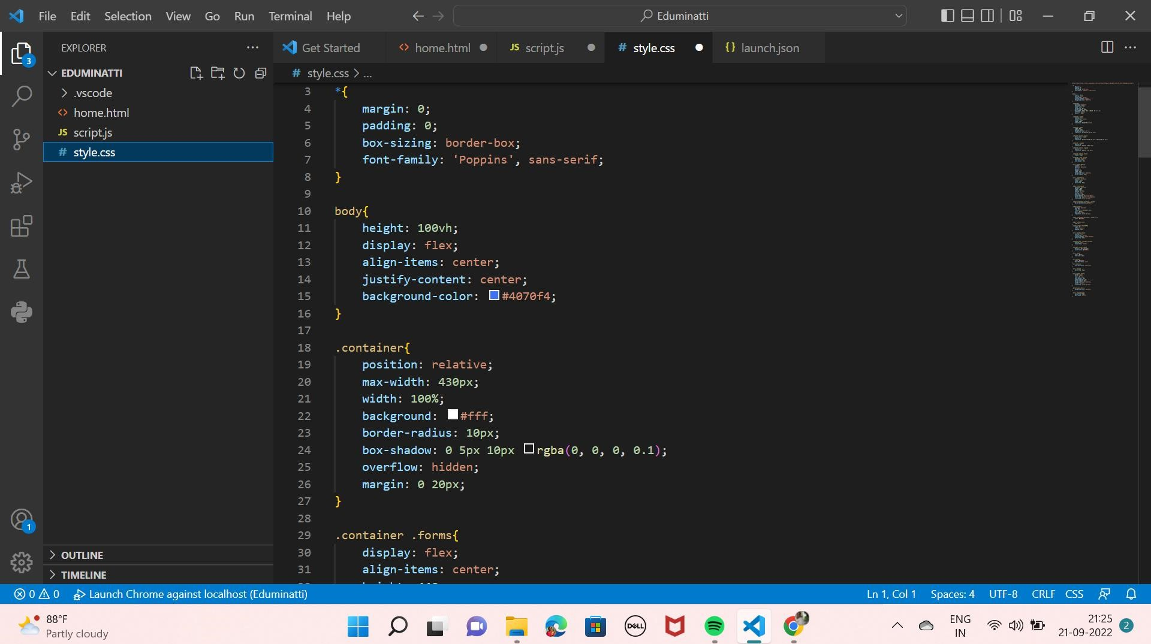

|  |  |  |  |  |
| --- | --- | --- | --- | --- |
|  | 23 | border-radius: lepx; |  |  |
| home.html | 24 | box-shadow: e 5px 18px rgba (e, | e, | e, |
| script.js | 25 | overflow: hidden; |  |  |
| style.css | 26  27  28  29 30  31  32  33  34  35  36  37  38  39  4e  41 | margin: e 2epx;  . container . forms{  display: flex; align-items: center; height: 44epx; width: 2ee%; transition: height e.2s ease;  . container . form{ width: 50%; padding: 38px; background - color : #fff ; |  |  |
|  | 42  43  44 | transition: margin-left 0.18s ease; | |  |
|  | 45 | . container.active . login{ | |  |
|  | 46 | margin-left: -50% | |  |
|  | 47 | opacity: e; | |  |
|  | 48  49 | transition: margin-left e. 18s ease, | | opacity e.15s ease; |
|  | 51 | . container . signup{ | |  |

n 1, Col paces: UTF-8 CRL csS

46 margin-left: -50% home.html 47 opacity: e; script.js 48 transition: margin-left 0.18s ease, opacity e.15s ease;

49

style.css

50

1. . container . signup{
2. opacity: e;
3. transition: opacity e .09s ease;

54

1. . container. active . signup{
2. opacity: 1;
3. transition: opacity e.2s ease;

58

59

1. . container. active . forms{
2. height: 6eepx;

62

1. . container . form . title{
2. position: relative;

### 65 font-size: 27px;

66 font-weight: 6ee;

67

68

69 . form . title: : before{

OneDrive 70 content :

71 position: absolute;

Screenshot saved

## 72 left: e;

The screenshot was added to your

1. bottom: e;

OneDrive.

1. height: 3px;

spaces: C KLI-

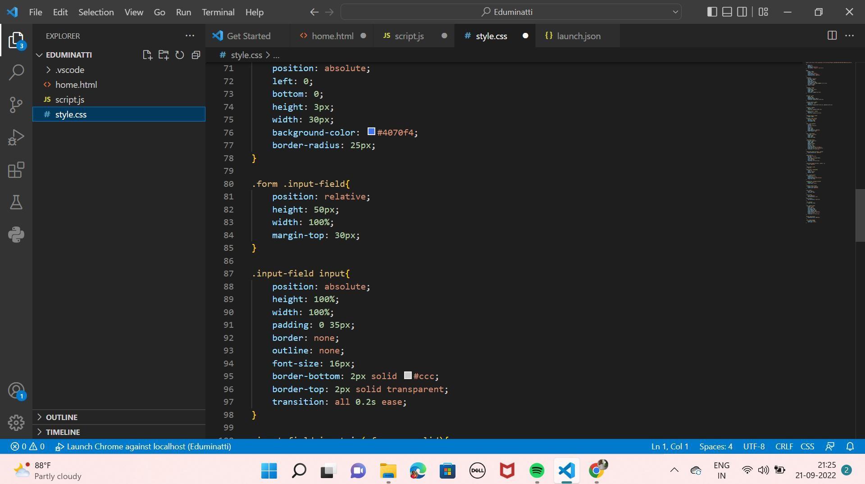

|  |  |  |
| --- | --- | --- |
|  | 93 | outline: none; |
| home.html | 94 | font-size: 16px; |
| script.js | 95 | border-bottom: 2px solid #ccc; |
| style.css | 96 | border-top: 2px solid transparent; |
|  | 97  98  99 | transition: all e.2s ease; |
|  | lee | . input-field input: is(:focus, : valid) { |
|  | lei 102 le3 | border-bottom-color: O #497ef4; |
|  | le4 | . input-field i{ |
|  | les | position: absolute; |
|  | les | top: 50%; |
|  | le7 | transform: translateY( -5e%) • |
|  | le8 | color: O#999 ; |
|  | le9 | font-size: 23px; |
|  | 110  111  112 | transition: all e.2s ease; |
|  | 113 | . input-field input:is(:focus, : valid) |
|  | 114  115  116 | color: #4e7ef4; |
|  | 117 | . input -field i. icon{ |
|  | 118  119 | left: e; |
|  | 120 | . input -field i . showHidePw{ |
|  | 121 | right: e; |

n 1, Col paces: UTF-8 CRL csS

O • JS

>

. input-neaa input: : tocus, : valid)

1. color : O #4e70f4; home.html
2. script.js 116 style.css 117 . input-field i. icon{

118 left: e;

119

### 120 . input-field i. showHidePw{

1. right: e;
2. cursor: pointer;
3. padding: lepx;

124

125

1. . form . checkbox-text{
2. display: flex;
3. align-items: center;

### 129 justify-content: space-between;

130 margin-top: 2epx;

131

132

133 . checkbox-text . checkbox- content{

### 134 display: flex;

135 align-items: center;

136

1. OneDrive
2. . checkbox- content input{
3. margin: e 8px -2px 4px; Screenshot saved
4. accent -color : O #4e70f4; The screenshot was added to your

141

OneDrive.

spaces: C KLI-

JS

>

|  |  |  |
| --- | --- | --- |
|  | 136 |  |
| home.html | 137 |  |
| script.js | 138 | . checkbox- content input{ |
| style.css | 139 | margin: e 8px -2px 4px; |
|  | 140  141  142 | accent -color : O #4e70f4; |
|  | 143 | . form . text{ |
|  | 144 | color : #333; |
|  | 145  146  147 | font-size: 14px; |
|  | 148 | . form a.text{ |
|  | 149 | color: O #4070f4; |
|  | Ise  151 | text -decoration : none; |
|  | 152 | . form a: hover{ |
|  | 153 154  155 | text-decoration: underline; |
|  | 156 | . form . button{ |
|  | 157  158  159 | margin -top : 35px; |
|  | 16e | . form . button input{ |
|  | 161 | border: none; |
|  | 162 | color : #fff ; |
|  | 163 | font-size: 17px; |
|  | 164 | font-weight: 500 • |

n 1, Col paces: UTF-8 CRL csS

